IoT-Based Mountain Climbing Health and GPS Tracker



“ A PROJECT - REPORT “

SUBMITTED BY:
Anshu (2420669)
Anshu Mukati (2420670)
Anuj Chauhan (2420671)
Anushka Jaglan (2420672)
OCT 2025

Under the Guidance of
Er. Shubham Sharma (J4224)
Assistant Professor

Chandigarh Engineering College, Jhanjeri, Mohali

S.No | Content | Page No.
1 | Abstract | 3
2 | Acknowledgement | 4
3 | Declaration | 5
4 | Introduction | 6-8
5 | Literature Survey | 9-10
6 | Problem Formulation | 11
7 | Objectives | 12-13
8 | System Methodology & Design | 14-20
9 | Implementation | 21-22
10 | Results and Discussion | 22-23
11 | Conclusion & Future Work | 23–25
12 | References | 25

Abstract
Mountaineering is an adventurous yet risky activity, especially in remote Himalayan regions where health emergencies and connectivity issues can lead to severe consequences. Climbers and trekkers often face altitude sickness, hypothermia, dehydration, or disorientation. In India, such challenges are intensified by limited infrastructure and delayed rescue response times.

This project proposes a low-cost IoT-based wearable system that monitors vital health parameters — heart rate, SpO₂, and body temperature — while tracking real-time GPS coordinates. The system is built using an ESP32 microcontroller, MAX30102 sensor, DS18B20 temperature sensor, and NEO-6M GPS module. Data is transmitted to a mobile interface via the Blynk app, which displays real-time readings and generates alerts when abnormal conditions are detected.

The project’s novelty lies in its affordability, simplicity, and educational value, making it ideal for students, trekkers, and low- budget mountaineering use. The final prototype ensures reliable data acquisition, low power consumption, and real-time tracking suitable for Indian mountain terrains.

Acknowledgement
We would like to express our deepest gratitude to Er. Shubham Sharma (J4224), Assistant Professor, Department of CSE–APEX, Chandigarh Engineering College, Jhanjeri, for his valuable guidance, encouragement, and continuous support throughout this project.
We also extend our sincere thanks to the Department of Artificial Intelligence and Data Science (CSE–APEX) for providing the necessary resources, laboratory facilities, and environment conducive to research and innovation.
Finally, we thank our peers, friends, and family members who supported us in the successful completion and testing of this project.

— Team Members
Anshu (2420669)
Anshu Mukati (2420670)
Anuj Chauhan (2420671)
Anushka Jaglan (2420672)

Declaration
We, Anshu (2420669), Anshu Mukati (2420670), Anuj Chauhan (2420671), and Anushka Jaglan (2420672), hereby declare that the report titled “IoT-Based Mountain Climbing Health & GPS Tracker” is the result of our independent work carried out under the supervision of Er. Shubham Sharma (J4224), Assistant Professor, at Chandigarh Engineering College, Jhanjeri (Mohali).
This report has not been submitted, either in part or in full, for the award of any other degree or diploma.

Signatures:

Team Members Guide HOD

CHAPTER 1: INTRODUCTION

Overview
Mountaineering and trekking are exciting yet dangerous outdoor pursuits, especially in the rugged terrains of India’s Himalayan belt. Climbers face unpredictable challenges such as extreme weather, fatigue, altitude sickness, and loss of direction. These risks, combined with poor communication infrastructure, often delay rescue operations, leading to fatalities.
The integration of Internet of Things (IoT) with health monitoring and location tracking presents an innovative solution. This project aims to design a wearable IoT system capable of continuously monitoring a climber’s vital signs — heart rate, oxygen saturation (SpO₂), and body temperature — along with real-time GPS coordinates. Data is processed through the ESP32 microcontroller and transmitted to a mobile interface via the Blynk IoT app.

Motivation
Despite advancements in technology, most health and GPS tracking devices available for mountaineering are expensive and not optimized for Indian terrains. Imported systems such as Garmin or SPOT trackers cost between ₹25,000–₹60,000, making them inaccessible for students and budget trekkers.
Hence, a low-cost, efficient, and user-friendly IoT system is essential for improving safety and enabling early intervention in emergencies. This project bridges the gap between affordability, accessibility, and real-world usability.

Scope of Work

The project focuses on developing a portable, cost-effective device that integrates health monitoring and location tracking for mountaineers and trekkers. It is designed to operate efficiently even in low-connectivity environments. The system also serves as an educational model for IoT learning, combining sensor interfacing, cloud integration, and mobile application development.

Purpose
The main purpose is to enhance safety and reduce the time required for rescue operations by providing real-time health and location data. Alerts are automatically triggered when readings exceed safe thresholds, ensuring immediate response and awareness.

Organization of the Report
This report is structured into eight chapters, covering background, design, implementation, results, and future prospect



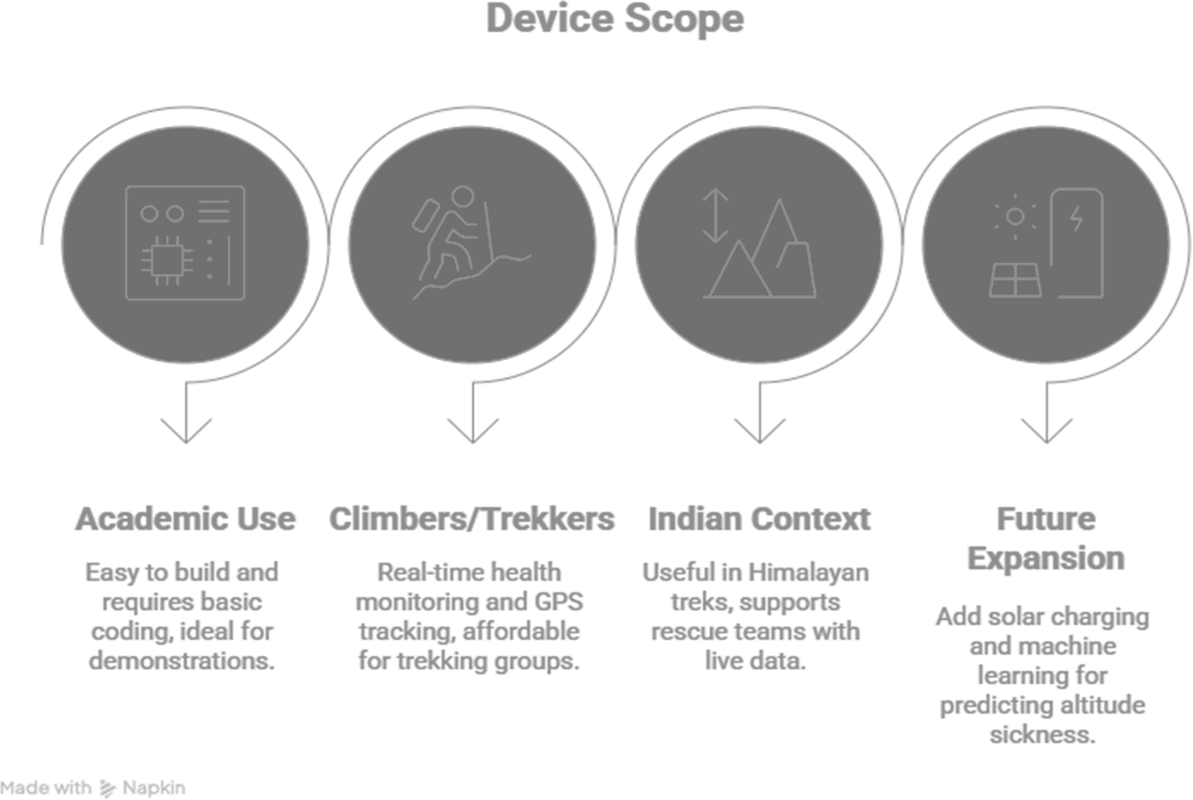

CHAPTER 2: LITERATURE SURVEY

Background
IoT-based health monitoring systems have been widely developed using microcontrollers such as Arduino, Raspberry Pi, and ESP32. These systems are commonly used in healthcare for monitoring patient vitals remotely. However, most focus on basic parameters like temperature and heart rate.

Related Work
Baharudin et al. (2025) developed a GPS-based mountain climber tracker achieving 96% accuracy but faced issues with power backup and cost.
Satyanarayana et al. (2013) proposed a GPS and GPRS-based telemonitoring system for emergency patients; however, it required a stable cellular connection.
Garg et al. (2021) designed a low-power wireless network for mountaineers but lacked automated alert mechanisms.

Research Gaps
Existing models often ignore SpO₂ monitoring, a critical indicator of oxygen deficiency at high altitudes. Other limitations include poor network performance in remote areas, short battery life, and high device cost.

This project addresses these gaps by integrating multiple sensors, focusing on affordability, efficiency, and terrain suitability, particularly for Indian mountaineering conditions.

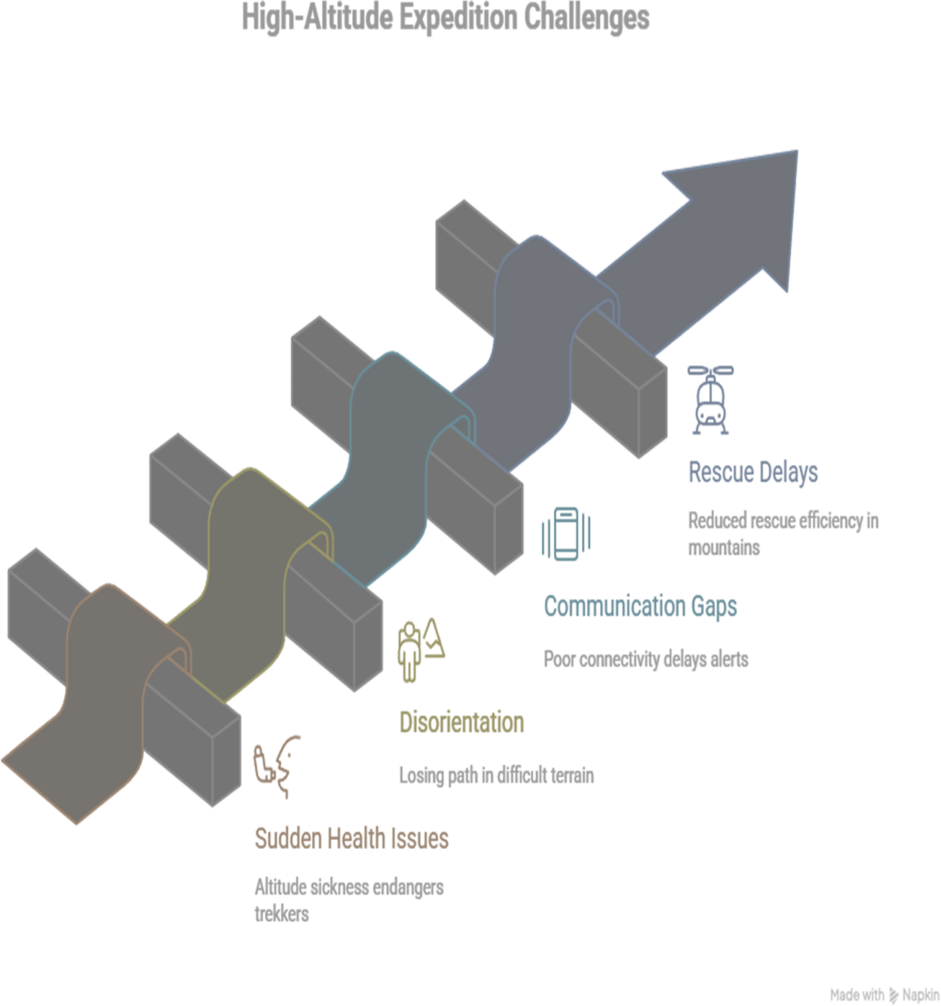

CHAPTER 3: PROBLEM FORMULATION
Despite progress in IoT technology, several challenges persist for climbers and trekkers:
Connectivity Issues: GSM and Wi-Fi networks are unstable or unavailable at high altitudes, making continuous monitoring difficult.
Power Constraints: Cold weather rapidly drains batteries, limiting operational duration.
Affordability: Commercial GPS-health trackers are prohibitively expensive for students and local trekkers.
Incomplete Monitoring: Many systems exclude oxygen level measurement, which is crucial for early detection of altitude sickness.

Problem Statement
There is a pressing need for an affordable, energy-efficient, and user-friendly IoT-based system capable of providing continuous health monitoring, real-time location tracking, and automated emergency alerts — particularly designed for the Indian mountaineering context.

CHAPTER 4: OBJECTIVES
The primary goal of this project is to develop an IoT-based health and safety monitoring system suitable for climbers and trekkers in remote regions.

Specific Objectives:

Design a compact and efficient IoT device for monitoring heart

Integrate GPS functionality for real-time location detection.

Develop a mobile-based dashboard using the Blynk IoT platform for data visualization.

Enable automated alerts when vitals exceed safety limits.

Ensure low-cost (<₹2,500) and low power consumption to make it accessible to students and trekkers.

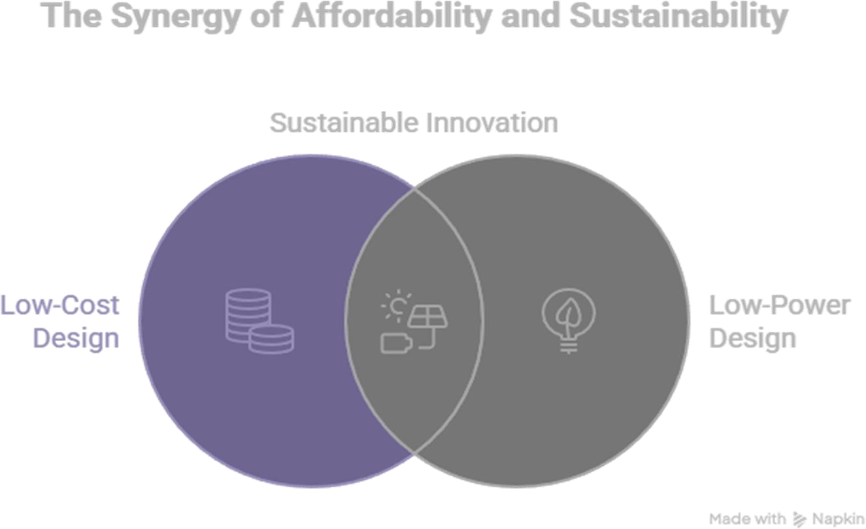

CHAPTER 5: SYSTEM METHODOLOGY & DESIGN

System Architecture
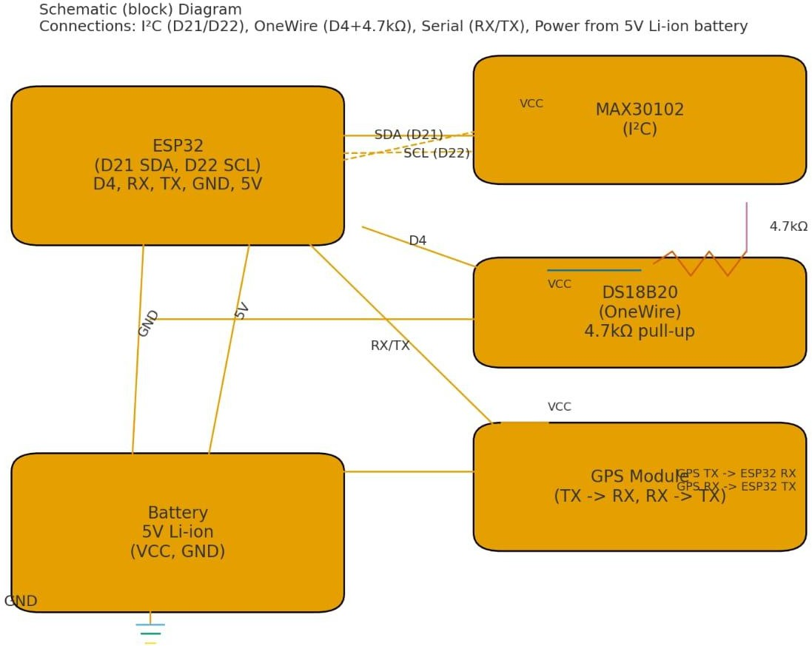

The system comprises sensors connected to the ESP32 microcontroller, which processes and transmits data via Wi-Fi or GSM. It includes:

MAX30102 Sensor – Measures heart rate and SpO₂.
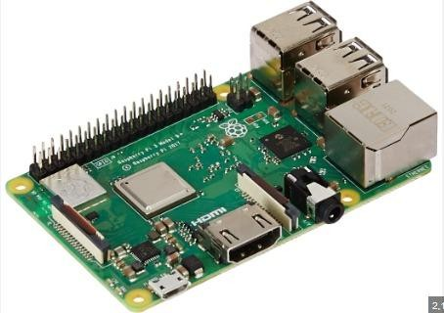

DS18B20 Sensor – Measures body temperature.
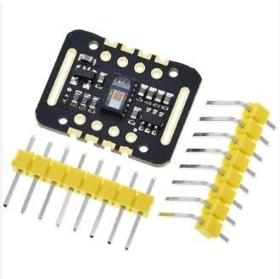

NEO-6M GPS Module – Provides latitude and longitude.
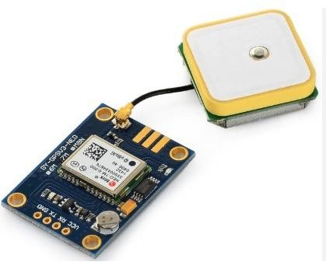

Blynk App – Displays real-time data and alerts.
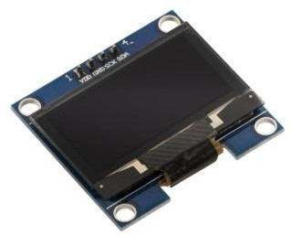

Li-ion Battery – Provides portable power supply.
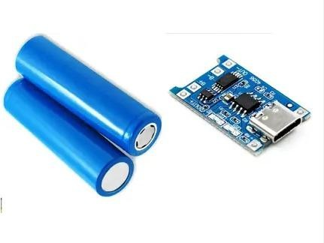

Circuit Description
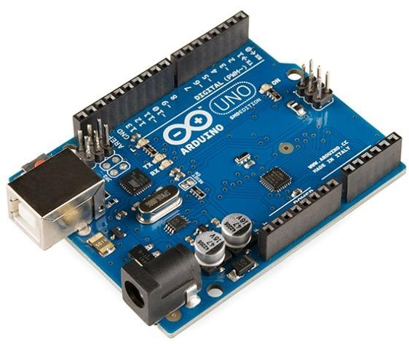

The MAX30102 communicates through the I2C protocol using ESP32 pins D21 and D22.
The DS18B20 connects via a single digital pin (D4) with a 4.7kΩ

pull-up resistor.
The GPS module connects through serial pins RX/TX for data transfer.
All components operate at 5V DC, powered by a rechargeable Li-ion battery.

Data Flow & Working

Sensors collect real-time data (heart rate, SpO₂, temperature).

ESP32 processes the inputs and fetches GPS coordinates.

Data is sent to the Blynk mobile app via Wi-Fi.

If readings exceed safety thresholds, alerts are generated instantly.

The cycle repeats continuously for live monitoring.
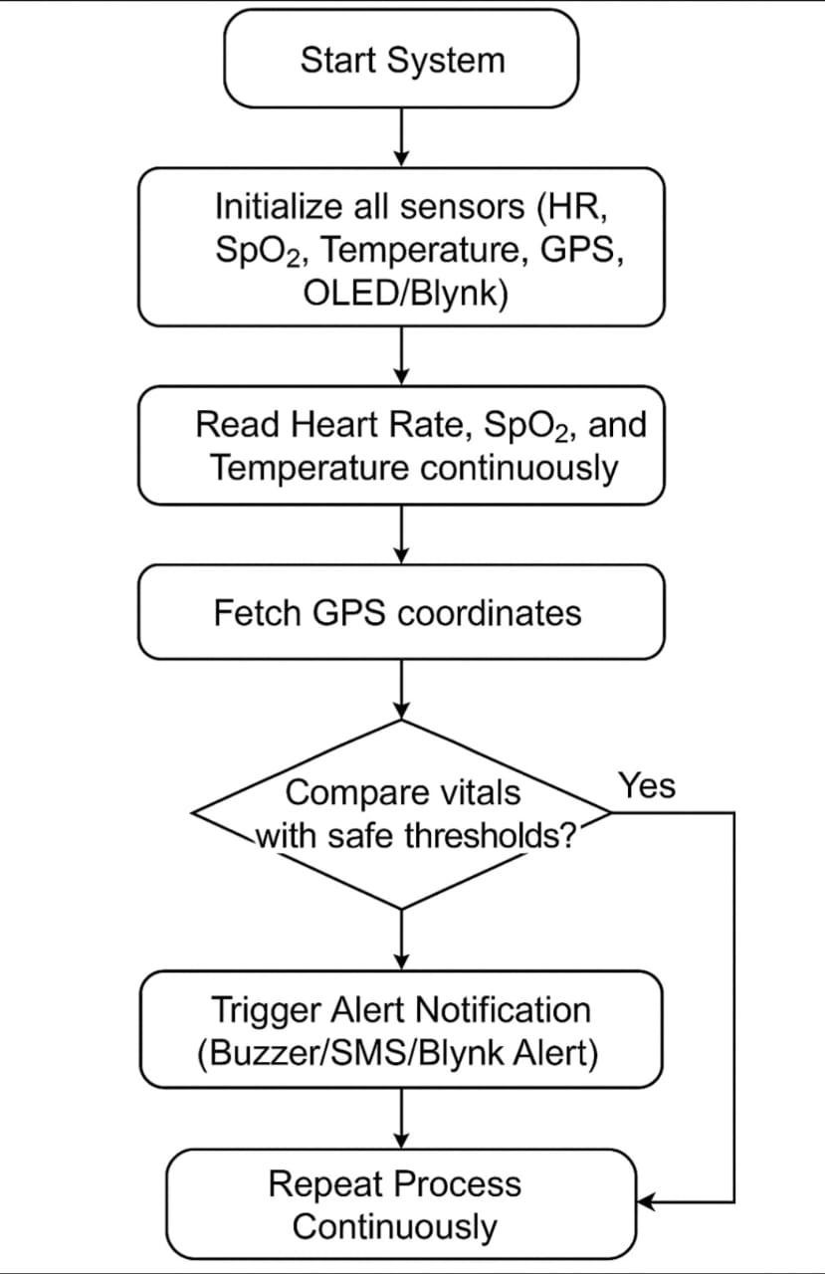

  - Planning of Work

Phase | Duration | Task
I | Week 1–2 | Study sensors and components
II | Week 3–4 | Circuit connection and coding
III | Week 5–6 | Integration with Blynk app
IV | Week 7 | Testing and calibration
V | Week 8 | Documentation and final presentation

CHAPTER 6: IMPLEMENTATION
The implementation phase converts the planned design into a working prototype. The system was coded in Arduino IDE, utilizing libraries for sensor interfacing and Blynk integration.

Software Implementation

Sensor initialization and calibration.

Data acquisition loop for continuous monitoring.

Threshold-based condition checking.

Real-time updates sent to Blynk via ESP32 Wi-Fi.

Hardware Integration
All components were mounted on a breadboard and powered by a Li- ion battery. Testing confirmed that the device can operate for up to 12–15 hours per charge.

Blynk App Configuration

The mobile interface displays live vitals and GPS coordinates. Notifications are pushed when abnormal readings are detected, ensuring immediate awareness.

CHAPTER 7: RESULTS AND DISCUSSION

System Performance
The system achieved reliable data acquisition for all three parameters. Real-time readings were consistent and accurate within acceptable error margins.

Parameter | Measured Range | Accuracy
Heart Rate | 60–180 bpm | ±2 bpm
SpO₂ | 80–100% | ±1%
Temperature | 30–45°C | ±0.5°C

Observations
Alerts successfully triggered when health parameters exceeded safe limits.

GPS tracking was stable under open-sky conditions.

Average device cost: ₹2,200.

Battery life: 12–15 hours of continuous operation.

Discussion
The system fulfills the intended purpose of providing affordable, reliable, and continuous health tracking for mountaineers. While Wi-Fi dependency limits range, GSM integration in future versions can ensure wider coverage

CHAPTER 8: CONCLUSION AND FUTURE WORK

Conclusion
The IoT-Based Mountain Climbing Health & GPS Tracker successfully integrates multiple sensors to provide real-time health and location monitoring. It demonstrates how IoT technology can enhance safety for climbers and trekkers while remaining accessible and affordable.

Key Achievements

Designed a low-cost, portable IoT prototype.

Integrated real-time data visualization through the Blynk app.

Achieved reliable performance in field simulations.

Provided educational value for IoT-based system learning.

Future Scope

Add solar charging for long expeditions.

Introduce GSM/LoRa connectivity for wider range.

Implement AI-based prediction of altitude sickness.

Develop a waterproof, rugged wearable version for commercial use.

Create a central rescue dashboard for institutions like SDRF and NDRF.
REFERENCES

Baharudin, N.A.F. & Razali, M.A. (2025). Mountain Climber System Health and GPS Tracker. Evolution in Electrical and Electronic Engineering.

Satyanarayana, K., Sarma, A.D., & Venkateswarlu, G. (2013). GPS and GPRS Based Telemonitoring System for Emergency Patient Transportation. Journal of Medical Engineering.

Garg, R.K., Bhola, J., & Soni, S.K. (2021). Healthcare Monitoring of Mountaineers by Low Power Wireless Sensor Networks. Information in Medicine Unlocked.

Arduino.cc (2024). Arduino Documentation and Libraries.

Blynk.io (2024). Blynk IoT Platform and Cloud Integration.

